

Analysis Of Rolling Compaction Operation Using Signal Processing And Machine Learning

*report by*

Pulkit Goyal

**TABLE OF CONTENTS**

1. Introduction 2

1.1. Inspiration 2

2. Analysis Procedure (Theory) 3

2.1. Data Measurement 3

2.2. Pre-Processing 4

2.3. Feature Elimination 5

2.4. Feature Extraction 5

2.4.1. Extra Features 5

2.5. Machine Learning 6

2.5.1. Proposed Model -- ANFIS 6

2.5.2. Motivation Behind Selecting ANFIS 7

2.5.3. ANFIS Compared to ANN (in general) 7

3. Analysis Results 8

3.1. Observations 10

3.2. Feature Preparation 11

3.3. Training 11

3.3.1. Numerical Details of the Dataset 12

3.3.2. Data Size Requirement 12

4. Conclusion 13

APPENDIX 14

I. Caveats in Data Measurement 14

# 

# 

# 1. Introduction

Rolling compaction is a very crucial operation in construction that is carried out to increase the soil density by applying stress to the landfill. These compactions are repeated until a certain soil density is reached.

Traditional methods of determining the soil density are expensive, time taking, and tedious; thus impractical. This project provides an alternative way of determining the soil density without actually measuring it, by measuring and analysing some physical parameters.

## 1.1. Inspiration

The hypothesis presumed in this project is that the vibration and acoustic data observed during a compaction operation are representative of the soil density.

It is based on the intuition that, as the soil density increases and the soil stiffness increases, the vibration frequency should increase, because gaps in the soil act as dampers that lower the natural frequency. So, as the gaps between the soil particles decrease with every compaction, the frequencies observed should increase.

This report gives experimental evidence in support of this theory by analysing data collected during rolling compaction.

Note: Based on experience, other parameters such as soil moisture, soil type, and ambient temperature/humidity are assumed to have an impact on this relation. These are not incorporated in the analysis results presented in this report, but they act as additional inputs to the proposed analytical (machine learning) model described in the next section.

# 

# 2. Analysis Procedure (Theory)

## 2.1. Data Measurement

We’ll focus on the acceleration and acoustic data observed as the rolling compactions as the main parameters. These measurements are collected using an onboard analyser. The acceleration is measured in three directions - X, Y, and Z.

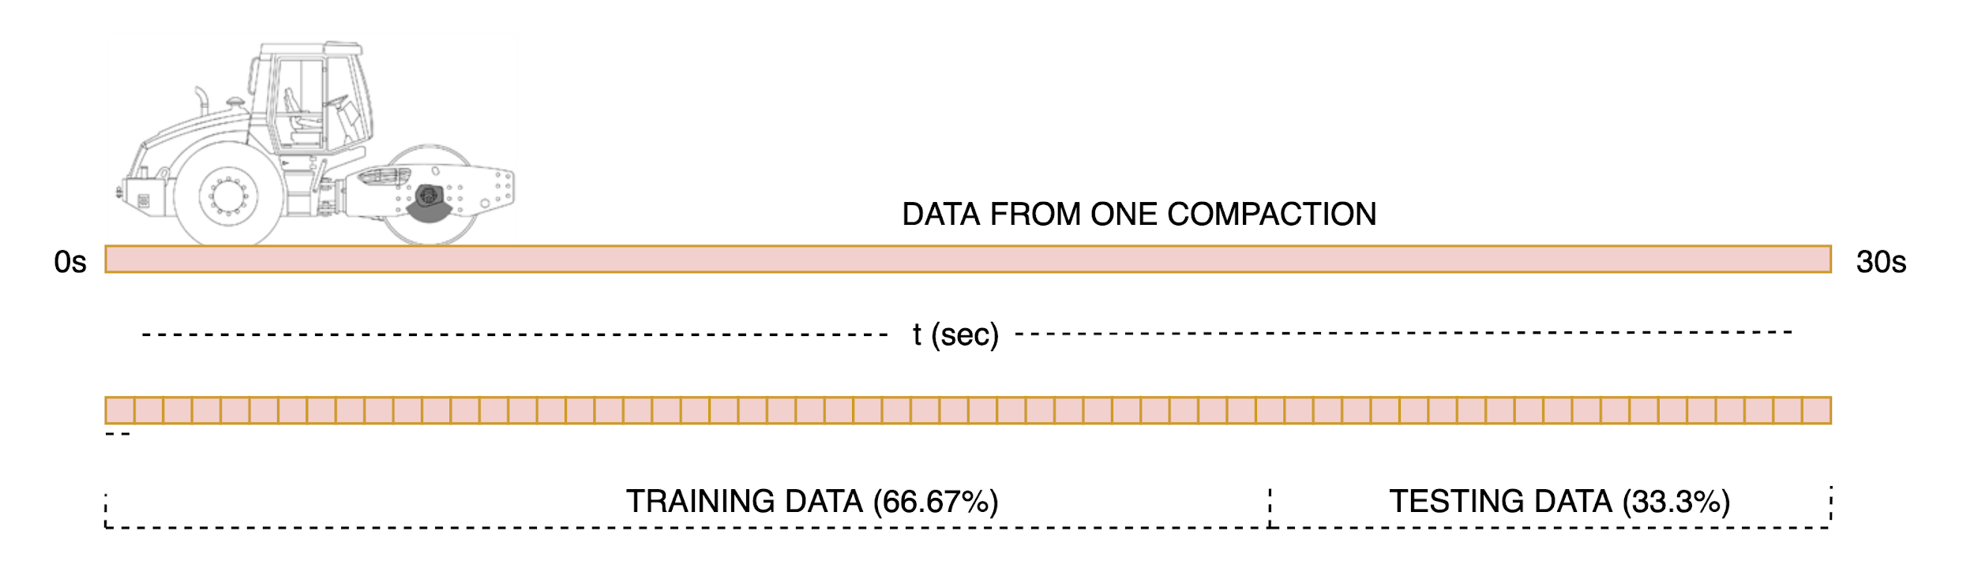

The soil density is subsequently measured after each compaction in three different places on the landfill using an RI (Radio Isotope) instrument to draw a correlation with the measured features. The RI instrument is calibrated using soil characteristics from lab tests.

The following flowchart shows how the data is collected.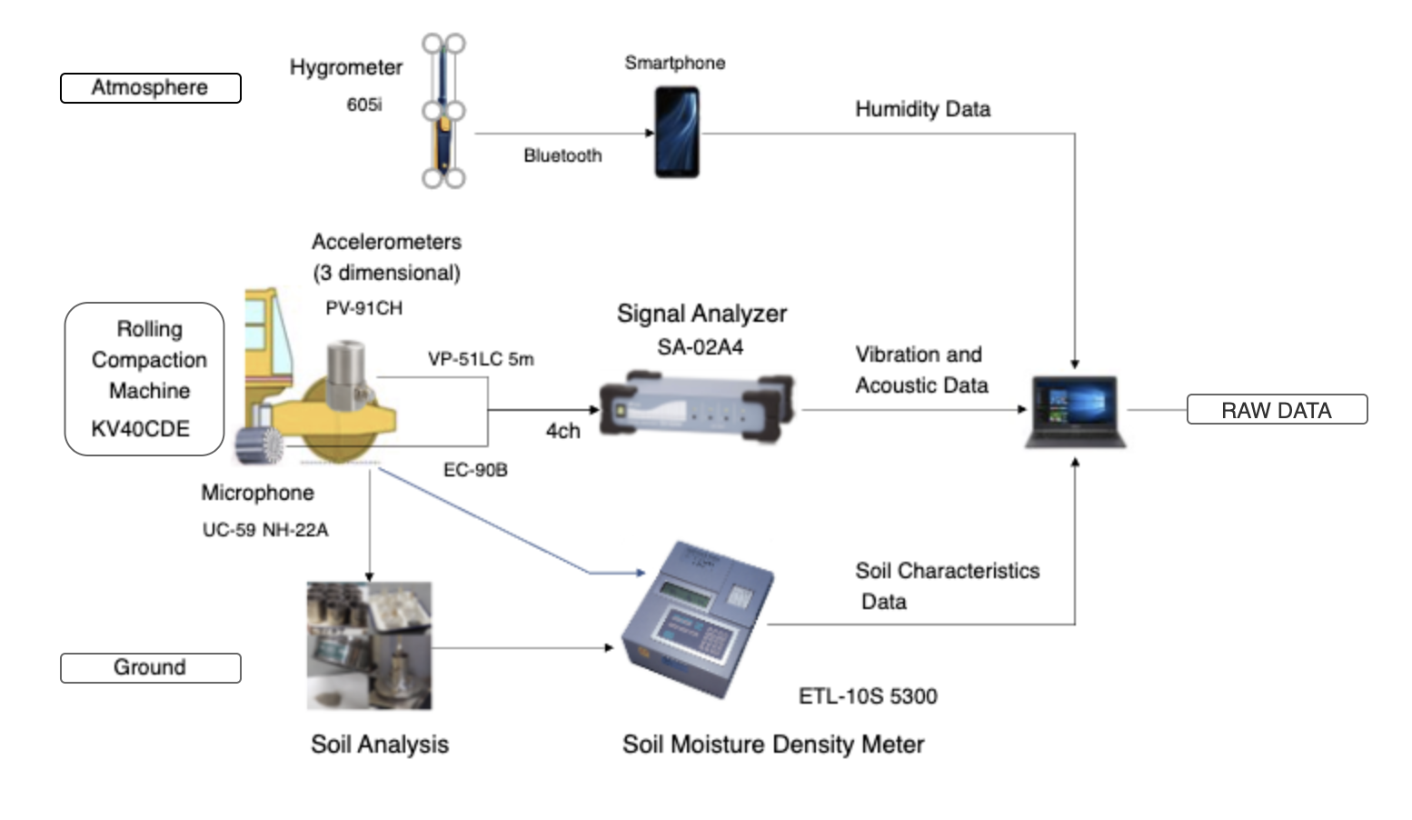

COMPLETE PROCESS

## 2.2. Pre-Processing

For each component (acceleration X-Y-Z and acoustic data), the following operations are performed.

* Normalized DFT of the acceleration (X, Y, and Z) and acoustic data is computed for each data set to obtain its profile in the frequency domain.
* Data is cleaned -- noise reduction is performed.
* The Power Spectral Density is calculated.
* The idling vibration and sound frequency of the compaction roller is subtracted.
* (optionally) The resultant of the X-Y-Z acceleration data is calculated.

NOTE: To accentuate important features in the data profile, each data set (from a compaction-run) can be split into a few subsets. The DFT of each of these subsets is then averaged to get a new profile.

After the initial pre-processing, representative features need to be identified and extracted to be input into the machine learning model. The next steps are,

* (optionally) Redundant components are eliminated with Principal Component Analysis, PCA.
* The dominant frequencies of *k* predefined ranges are determined from the signals.

## 2.3. Feature Elimination

It is important to eliminate redundant features, as having correlated input features may lead to overfitting and over-complexity, and in-turn poor performance and longer training time.

The acceleration and acoustic data are correlated to each other. So, using PCA the correlation between the two features can be checked, and if they are indeed strongly correlated, the feature with less variance is preferably removed from the input features.

## 2.4. Feature Extraction

The dominant frequencies of *k\** predefined ranges will be used as inputs to the model. These ranges lie around the noticeable crests throughout the signal (around overtones of 51 Hz).

*\* The number of frequencies, k, to accurately describe a profile may depend on the soil-type, but based on the current data,* ***k = 1 should suffice****, since the frequency shift trend is isotropic across the spectrum.*

The features proposed to be inputted to the model are,

* K dominant frequencies from acceleration (X-Y-Z) and acoustic data
* Weather data (Ambient Temperature and Humidity)
* Soil moisture level
* Soil type/class

### 2.4.1. Extra Features

Apart from using the constituent frequencies (pitch and amplitude) as a feature from the audio data, a few other features that are characteristic of *timbre* can be input into the model for further improvements. These include,

* spectral spread (a measure of bandwidth, tonality vs noisiness)
* kurtosis
* skewness

This paper lists a few other parameters that can be considered. - <http://recherche.ircam.fr/anasyn/peeters/ARTICLES/Peeters_2003_cuidadoaudiofeatures.pdf>

## 2.5. Machine Learning

### 2.5.1. Proposed Model -- ANFIS

ANFIS (Adaptive Neuro-Fuzzy Inference System) is basically a Sugeno fuzzy inference system represented under a neural network framework. The idea behind it is that it allows the training of a fuzzy system using the same data-driven principles used in ANN.

* The original paper is here - <https://www.dca.ufrn.br/~meneghet/FTP/anfis%2093.pdf>.
* An example of the implementation of an ANFIS system for a similar application can be read here - <https://ti.arc.nasa.gov/m/pub-archive/archive/SPIE_02_3_r.pdf>.
* A simple overview of Fuzzy System and ANFIS can be read here - <https://shodhganga.inflibnet.ac.in/bitstream/10603/24154/7/08_chapter%203.pdf>

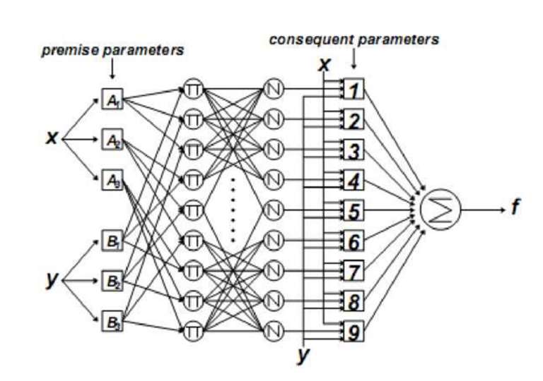

Two-input first-order Sugeno fuzzy model with nine rules

* Layer 1: *Input layer*
* Layer 2: *Fuzzification layer* that computes the membership value of the real inputs (*y* and *y*) in predefined fuzzy sets (A1, A2 and A3, A4). In this particular example, there are 3 (An) sets for the first input and 3 (Bn) sets for the second input.
* Layer 3: *AND layer* consisting of 3 x 3 (An x Bn) nodes. These represent all the combinations between membership sets of the inputs. In this layer, the outputs from the last layer are simply multiplied to obtain a “net firing strength” of that rule.
* Layer 4: *Normalization layer* consisting of 3 x 3 (An x Bn) nodes. This layer normalises its corresponding input based on other outputs from the previous layer.
* Layer 5: *Fuzzy inference layer* consisting of 3 x 3 (An x Bn) nodes. This layer computes the “inference value” based on the original inputs and the corresponding weights from the previous layer.
* Layer 6: *Defuzzification layer* with one node, which computes the crisp value by simply adding the outputs of the last layer.

The tunable parameters of an ANFIS system are

* *ai*, *bi*, and *ci* = premise parameters (properties of the membership functions)
* *pi*, *qi*, and *ri* = consequent parameters (properties of the inference system)

ANFIS models train with a hybrid training algorithm combining the least-squares method (in a forward pass) to optimize the consequent parameters and the gradient descent method (in a backward pass) to optimize the premise parameters.

### 2.5.2. Motivation Behind Selecting ANFIS

A fuzzy logic system, at its core, works by finding the belongingness/nearness or “membership” of an input data point to predefined membership sets to interpolate an output. So, in cases where it is known that the input values are distributed around certain fixed values, a fuzzy system can naturally represent the system.

In our case, the dominant frequencies after each compaction are expected to lie around certain values (overtones). The premise parameters can thus be initialised efficiently, as these overtones can perfectly represent the mean of the membership functions. This gives the impression that an ANFIS system can effectively model this system.

### 2.5.3. ANFIS Compared to ANN (in general)

While a conclusive study has not been published yet, the majority of studies to compare the performance of the two have stated that ANFIS typically has a slightly better performance than ANN. [<https://journals.sagepub.com/doi/pdf/10.1177/1847979018768421>]

Another notable advantage is that ANFIS models can generate linguistic rule sets that can be understood by humans, unlike ANN models which behave as black boxes.

An ANFIS system can be given accurate information about the properties of the system by selecting optimal membership functions because of its intuitive structure that maps directly to the system properties.

# 

# 3. Analysis Results

The description of the data used to plot the following graphs is as follows.

* Soil Type - Rekishutudo (礫土)
* Measurement Resolution - 195 µs
* Number of compactions - 3*
* Each compaction consisted of a forward and a backward run.

*\* The data from the second compaction is ignored due to some irregularities attributed to faulty measurement.*

The process described in the last section is presented below,

1. Raw Data (in the time domain) for the first and third/last compactions

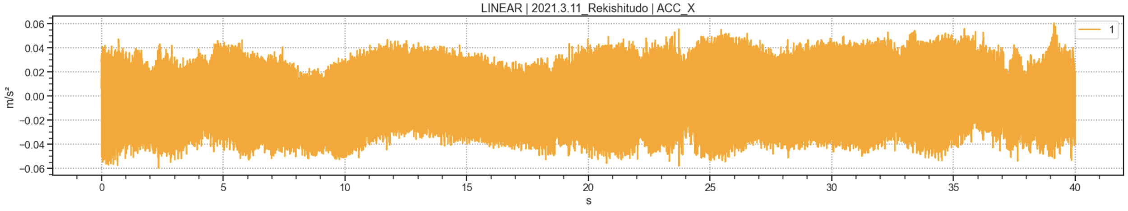

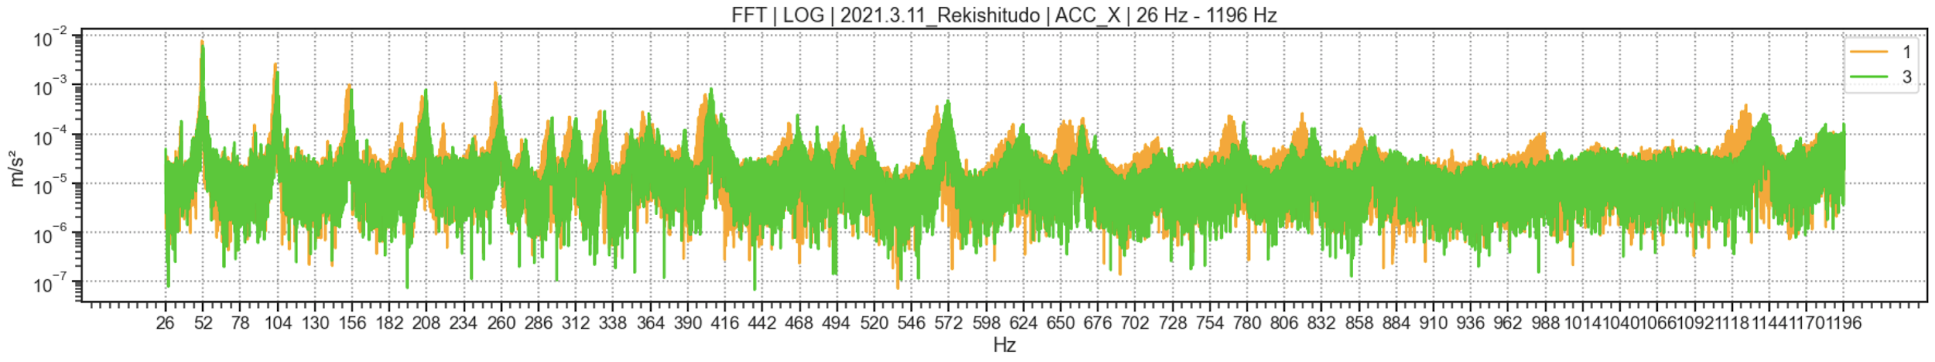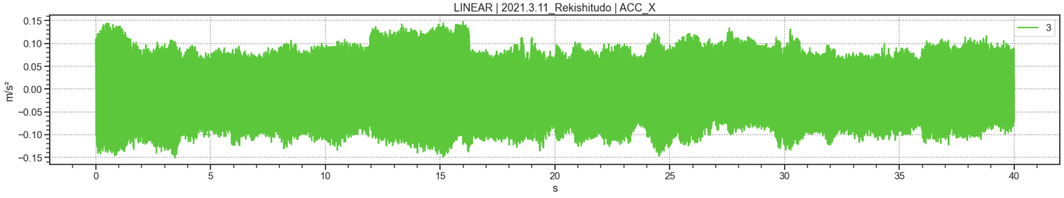

1. The DFT of the above data is calculated. The Power Spectral Density of the signal is plotted below.
2. The above frequency spectrum is noisy, so Welch Transform is used instead to remove the noise.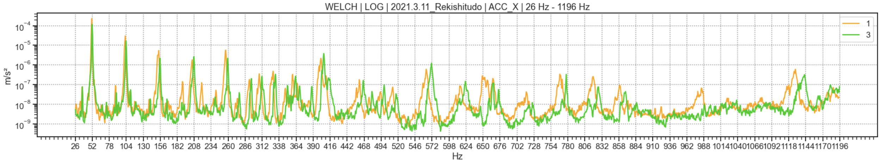
3. The results can be realized properly by zooming in on a narrower frequency band.  
   The pair on the top is the FTT (x100), and on the bottom is the result using Welch Transform.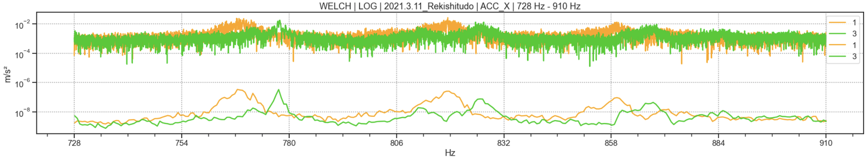
4. The following are the graphs of the Power Spectral Density calculated using Welch Transform

-- *Acceleration X*, *Acceleration Y*, *Acceleration Z*, and *Audio* (top to bottom).

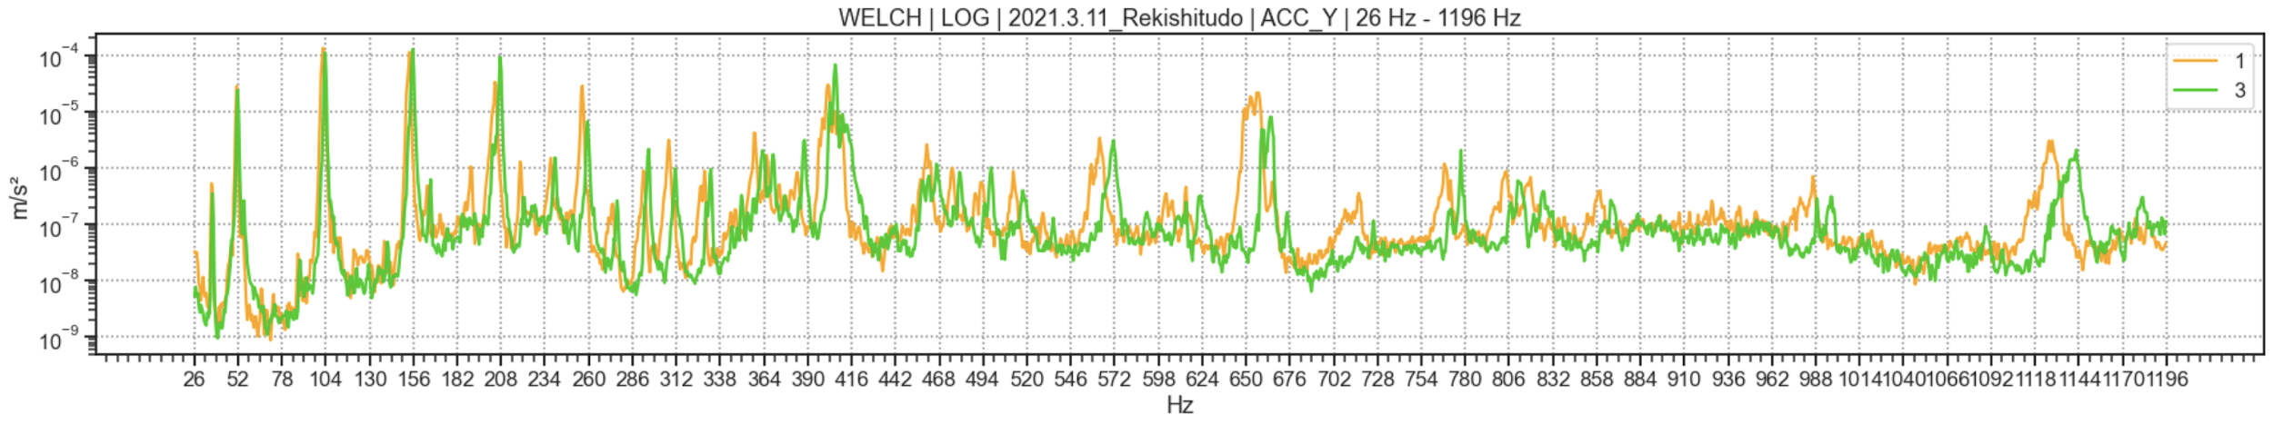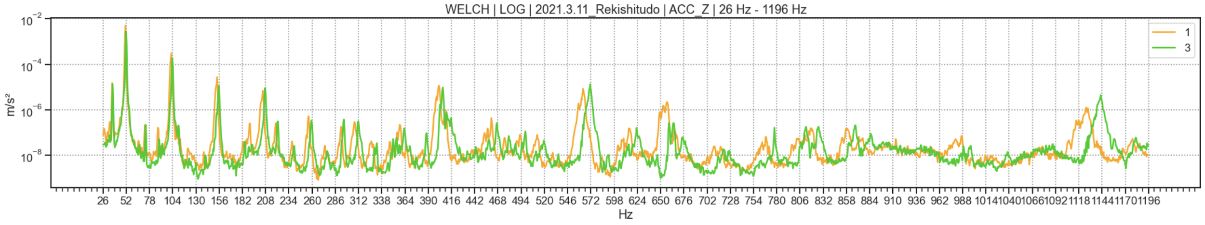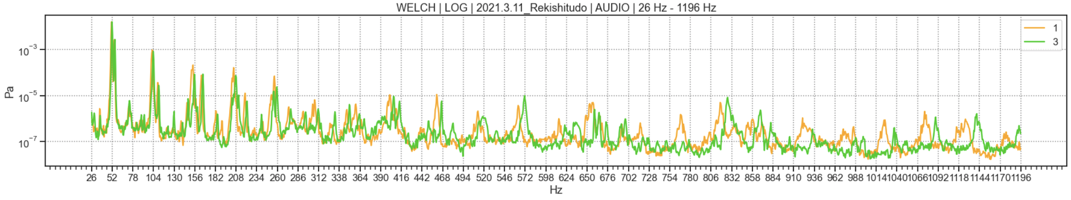

## 3.1. Observations

1. It can be observed that the dominant frequencies (peaks in the graph*) corresponding to the third/last compaction are greater than those of the first compaction.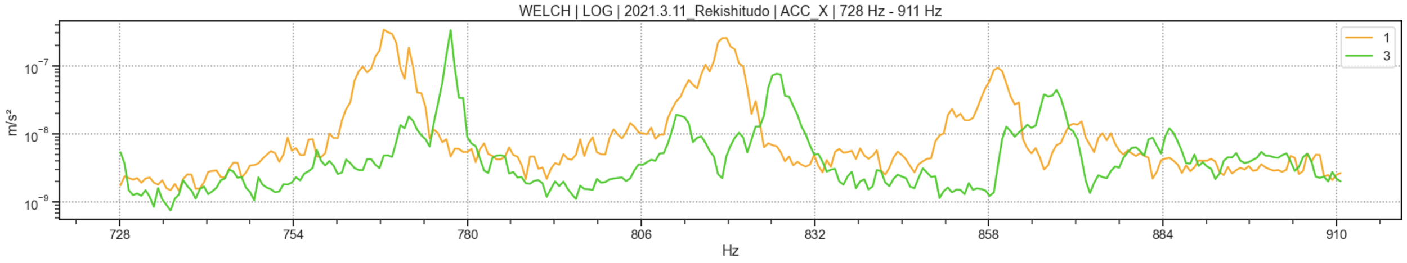

This is true for all the components (acceleration X-Y-Z and audio) across their profiles. With an increasing frequency, this shift increases. It can be inferred that it is the fundamental frequency that changes, and the shift is scaled at the subsequent overtones.

The fundamental frequency is calculated to have increased by a factor of **1.02** after compaction.

1. The soil density characteristics observed using the RI equipment show that the wet soil density and compactness increases steadily with the compactions.

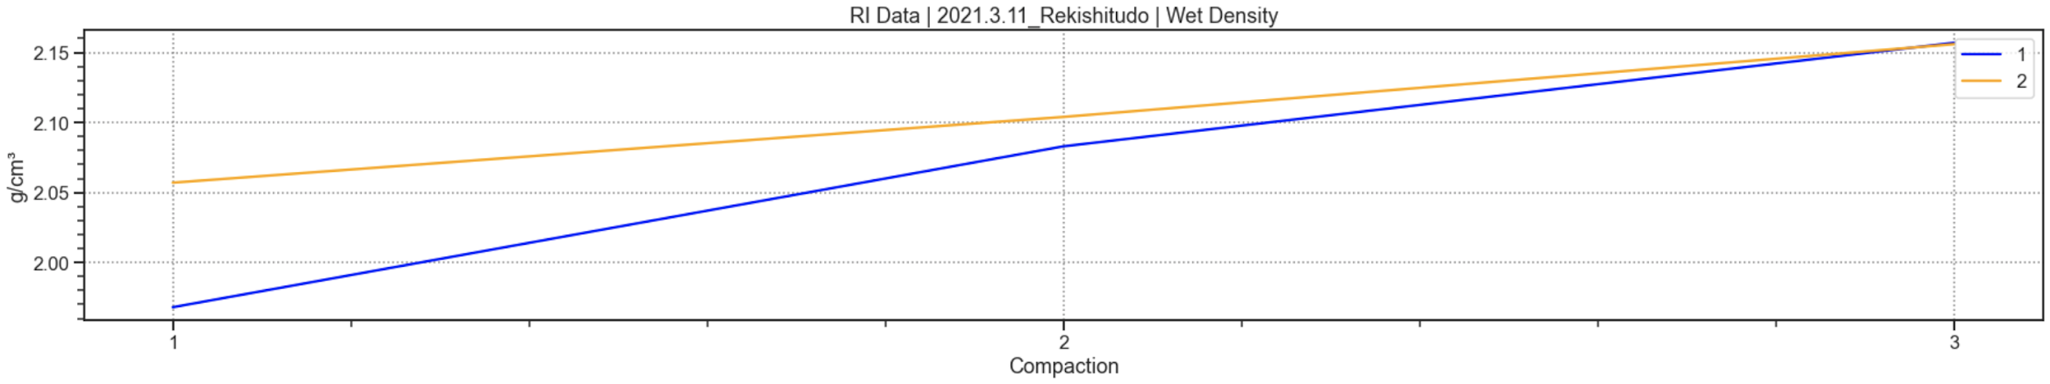

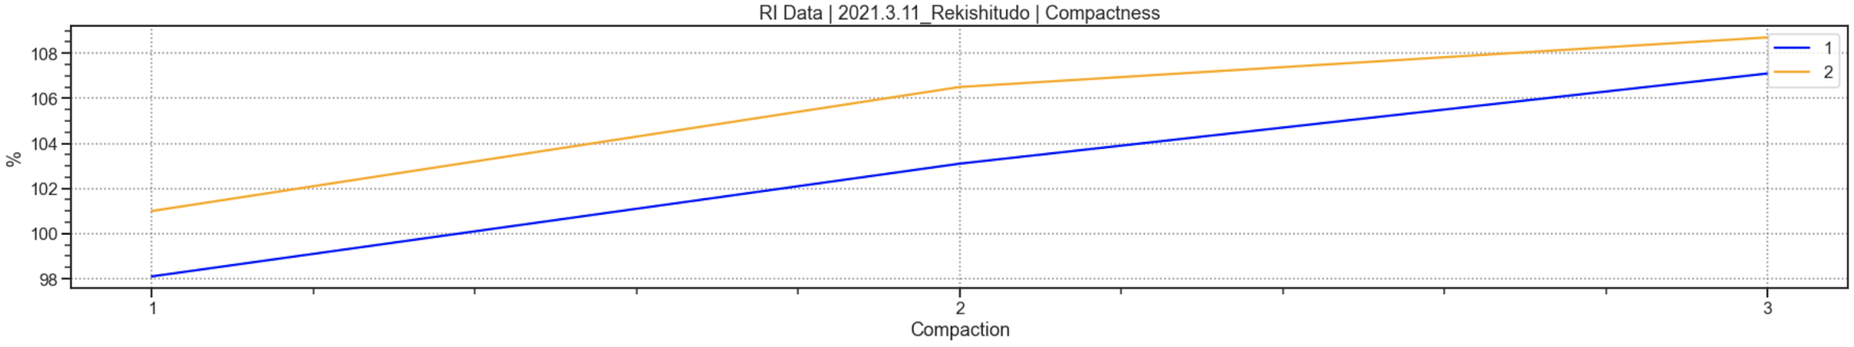

Both the fundamental frequency of vibration (and audio) and the wet soil density (or compactness) increase homogeneously with compaction. Thus, they are strongly correlated.

It serves as evidence to support the hypothesis that an analytical model can be developed to estimate the soil density from the vibration and acoustic information.

## 3.2. Feature Preparation

The graphs below show the placement of the Gaussian membership functions at overtones of 51 Hz (with a standard deviation of 4 Hz) for the ACC_X data in different ranges.

It can be seen that these membership functions align perfectly with the crests in the profile.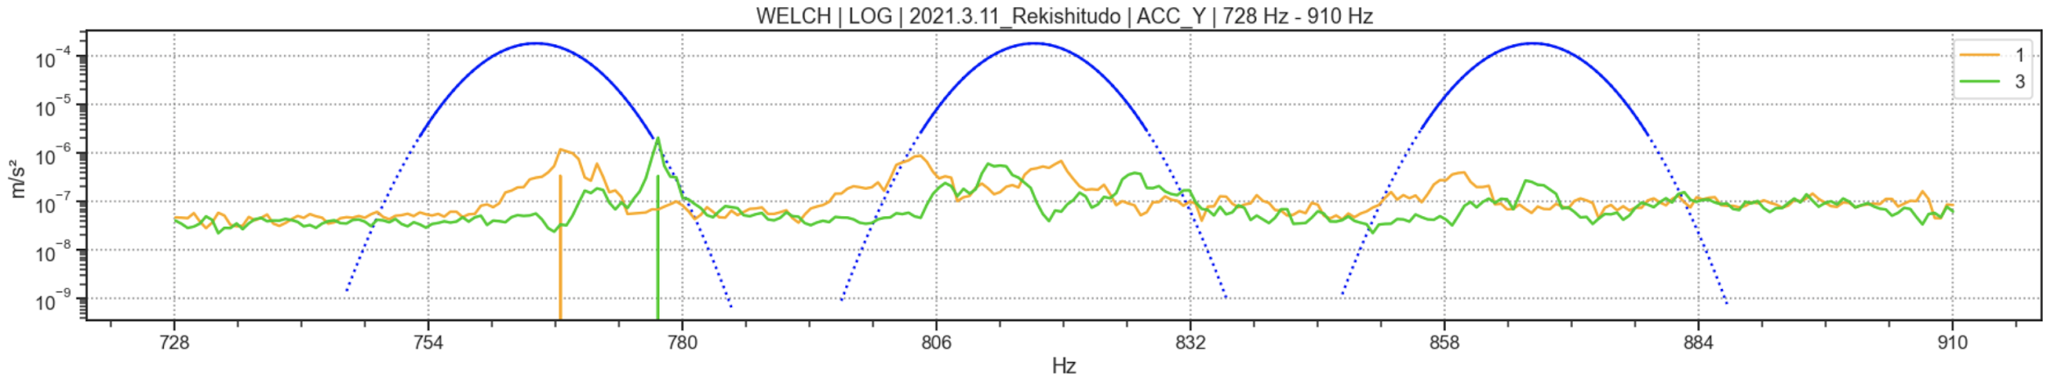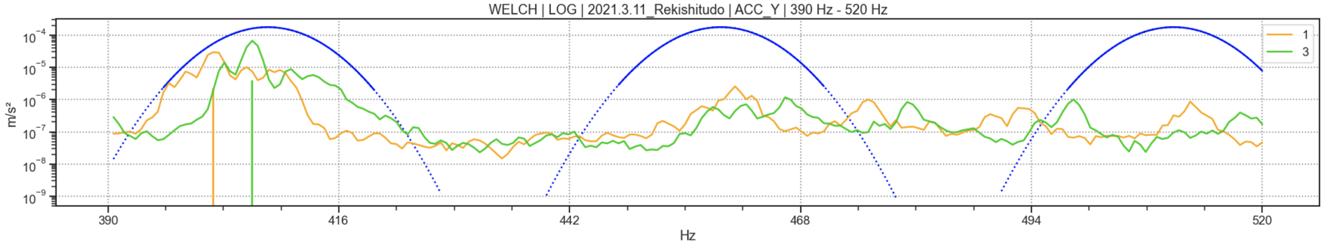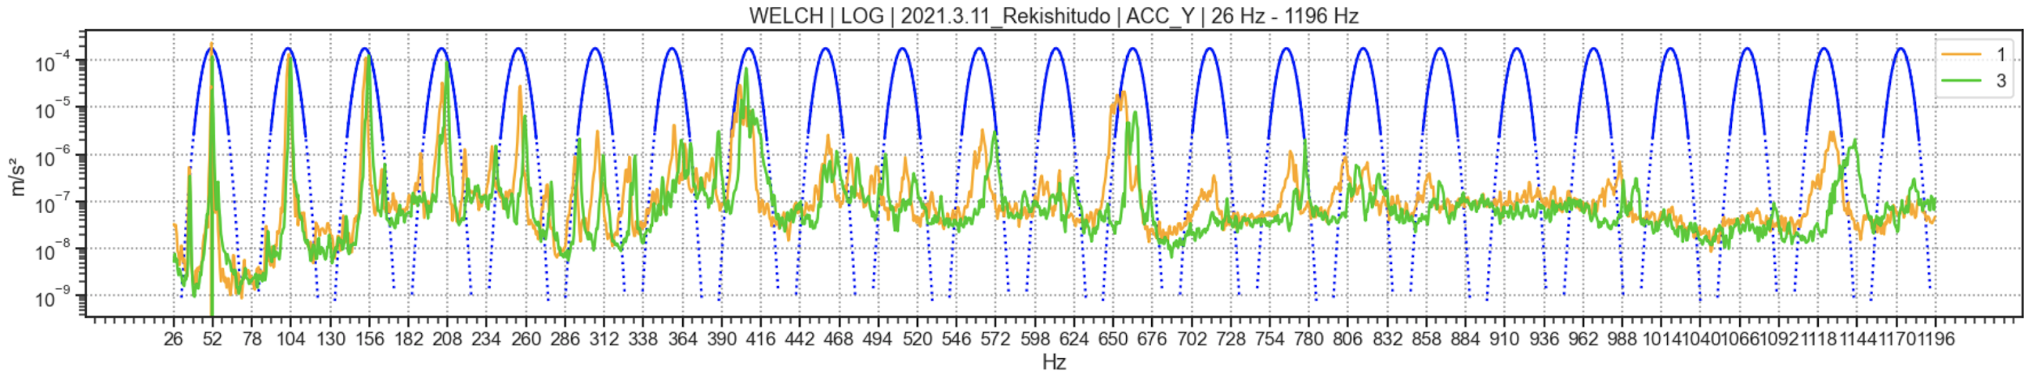

The ANFIS model is thus a fitting tool to model this problem.

## 3.3. Training

* The data points from each run are split in the ratio of 2:1 for training and testing respectively.
* Each data point is pre-processed, and its features are extracted.
* The model is then trained with these inputs against the RI data, particularly *compactness* (or *wet-soil density*).

### 3.3.1. Numerical Details of the Dataset

* Over 30 seconds of data is gathered from one compaction-run.
* Splitting the data into window sizes of 10 seconds results in three data points.
* Two of these data points will be used for training and the one remaining for training.
* The frequency range of DFT, at a sampling frequency of 5128Hz, will be [0.1 Hz, 2564 Hz].
* The frequency resolution is 0.1 Hz.

The typical frequency range in which features of interest exist, based on the analysis presented in this report, is [0 Hz, 1200 Hz]. This lies within the range of the frequency analysis, [0.05 Hz, 2564 Hz].

NOTE: the required bandwidth (1200 Hz) is half of the available bandwidth (2564 Hz). This allows doubling the data points -- by splitting every data point in two by taking every other measurement, i.e. at a sampling frequency of 2564 Hz, we can obtain a frequency range of [0.1 Hz, 1282 Hz] and six data points. Four of these can be used for training and the remaining two for testing.

### 3.3.2. Data Size Requirement

Assuming an average of four compactions in a run, a total of sixteen data points can be obtained per soil type for training the model along with eight data points for testing.

This is *not* enough to train a model. Thus, more data samples need to be obtained for a few different types of soils over a range of consecutive compactions (runs), at different levels of soil moisture, and ambient temperature and humidity, for training.

# 

# 4. Conclusion

Over multiple compactions, vibration and audio data for a soil type was collected and analysed to obtain its frequency profile, and RI data was also collected simultaneously and a correlation between the two was drawn. Based on the observations, the premise of the projects was validated -- the vibration and acoustic data can be used to estimate the soil density.

The ANFIS model was proposed and simply verified on the data obtained.

A large amount of data needs to be gathered over multiple compaction-runs to be able to develop (train) this model. To guarantee the robustness, accuracy, and flexibility of the model, this data must be collected, for each soil type, at different soil moisture levels (1), and under varying ambient conditions (2).

# APPENDIX

## Caveats in Data Measurement

**> Enough power input to the sensors must be ensured.**

* + The following graphs are drawn from the preliminary measurements in low-power conditions for Masado (マサド) soil type. As evident, no distinct trend/variation between compactions is visible.

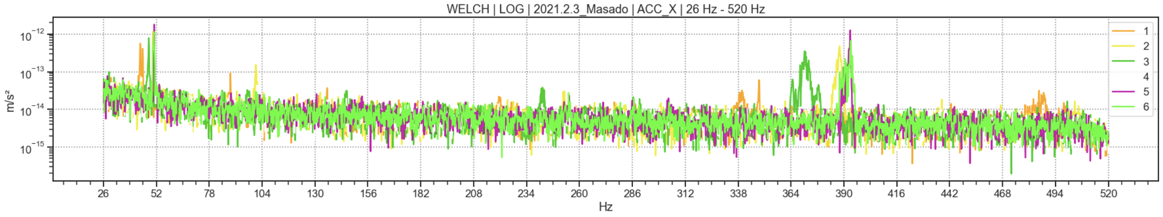

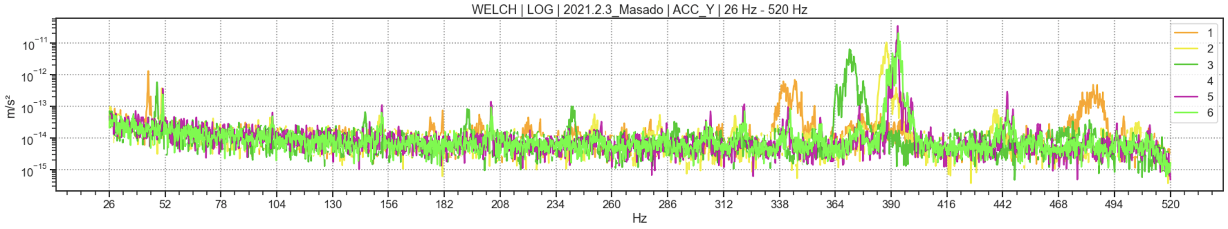

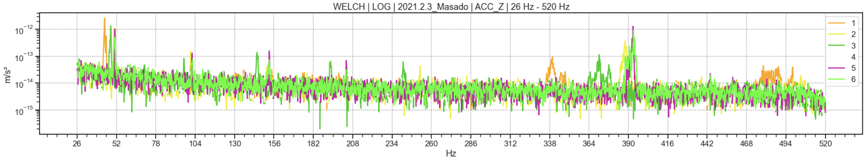

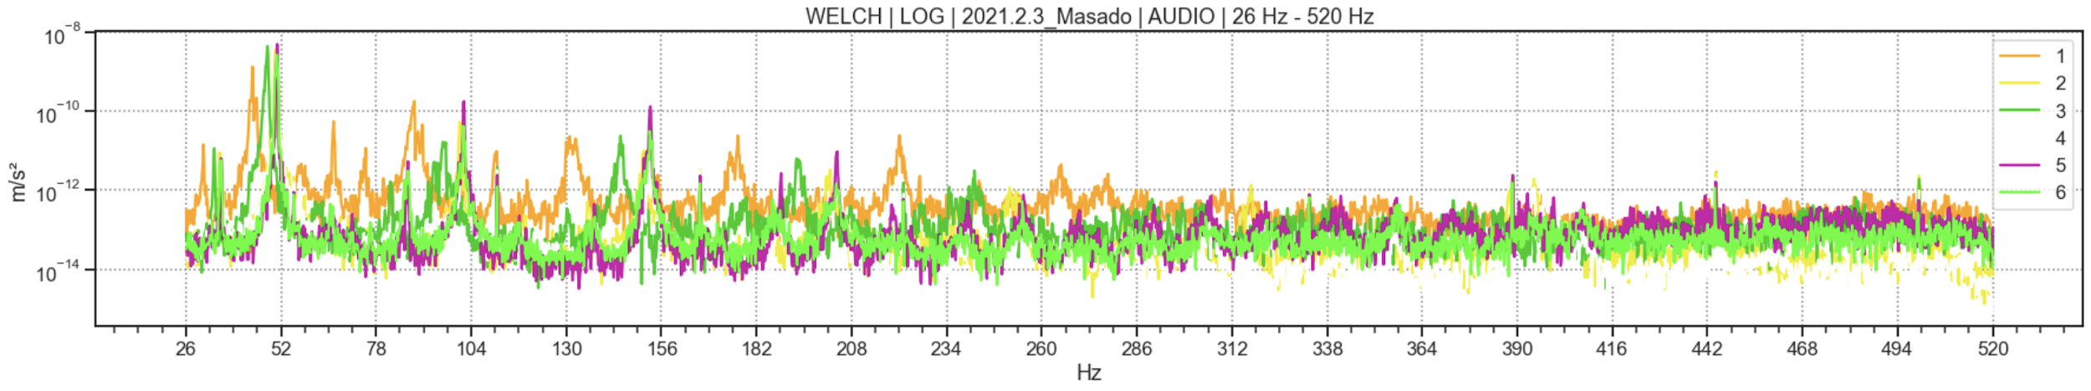

* + There is no discernable pattern even when zoomed-in i.e., the profiles are indistinct.

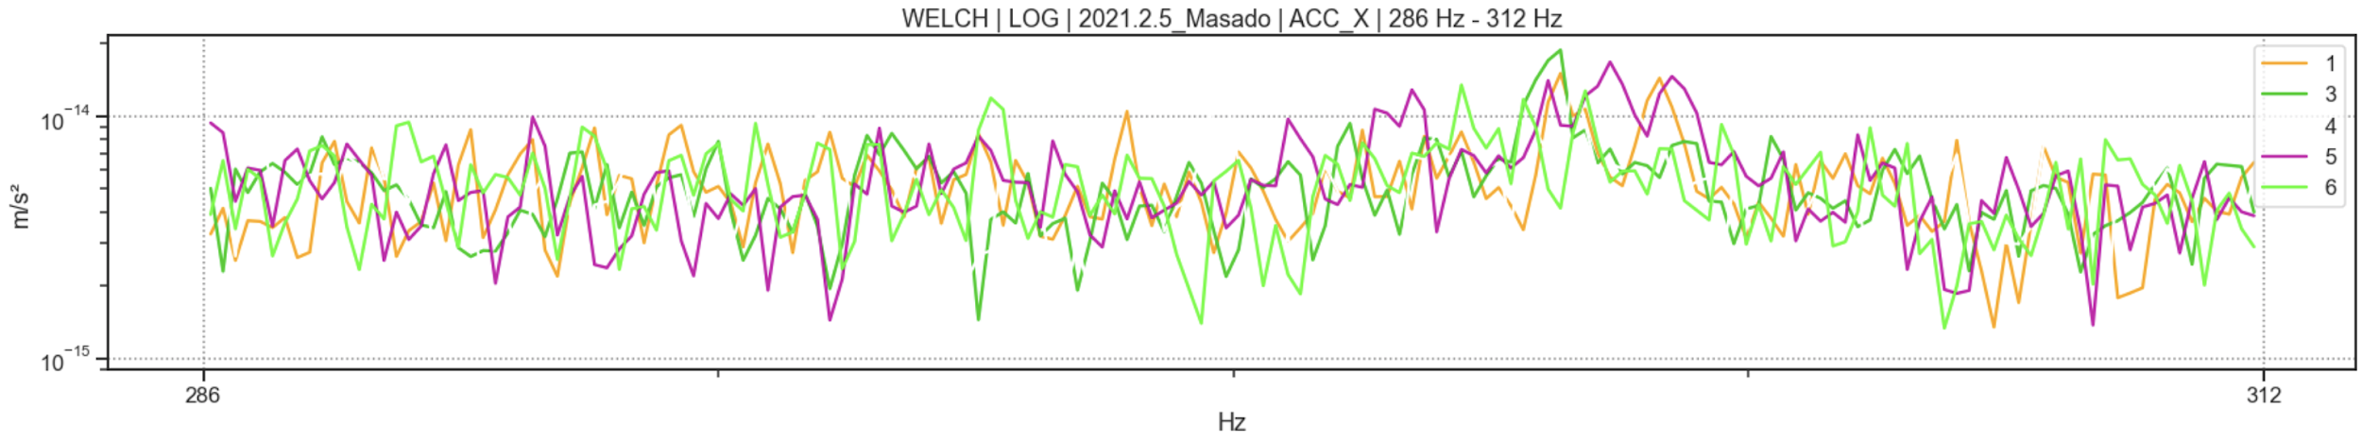

Thus, sufficient power to the sensors must be provided during measurement.